Creating Dashboards Using Spreadsheets

**Introduction to Dashboarding**

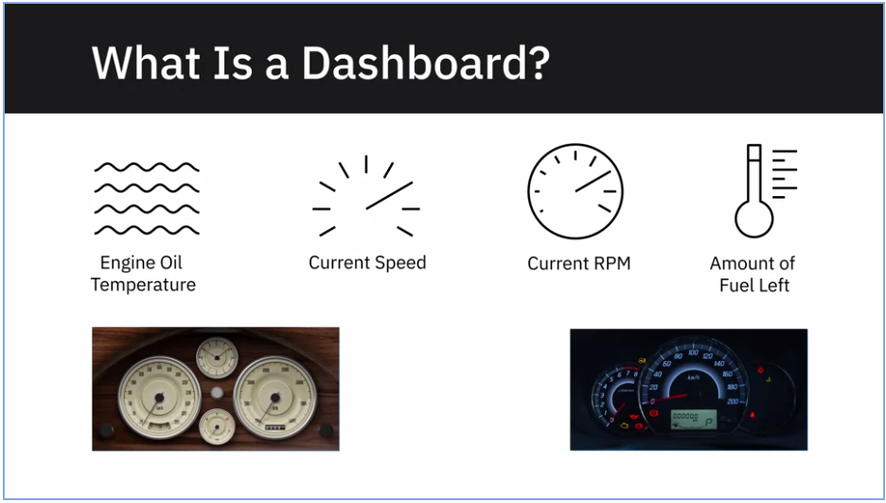

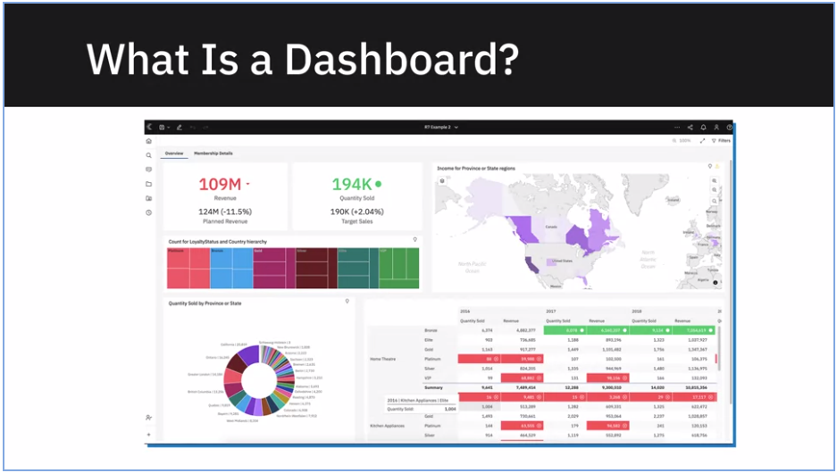

The term ‘dashboard’ comes from the automotive industry where car designers have put the most important gauges and other display information, such as engine oil temperature, current speed, current RPM, amount of fuel left, and so on, in a handy graphical display that is easy for the driver to view and understand. Originally these displays were analogue, but many are now digital and use varying forms of visualization, including digital meters and mini graphs. You can take that same idea and apply it to a dashboard in a data analysis application; designers of these types of dashboard want to put key business information in one place, in the form of graphical displays, to make it easier for the viewer to understand them.

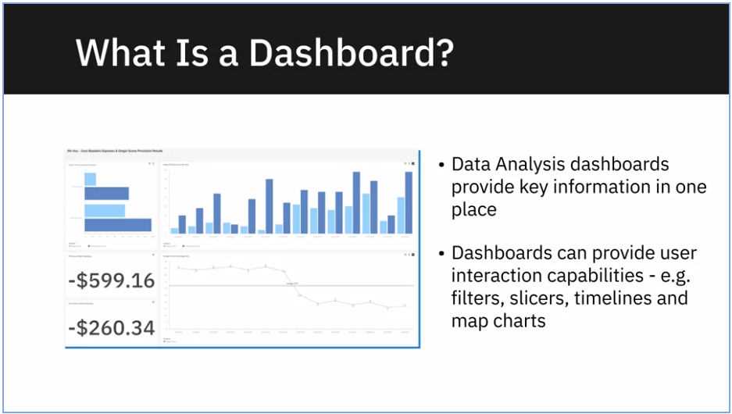

Dashboards can take this a step further by also allowing the user to interact with the dashboard and modify exactly what information they see by using tools supplied on the dashboard.

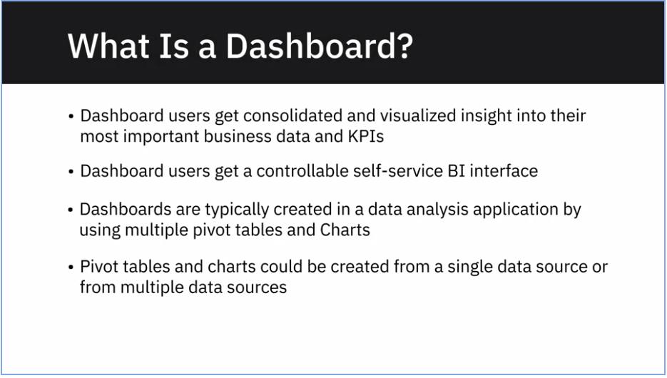

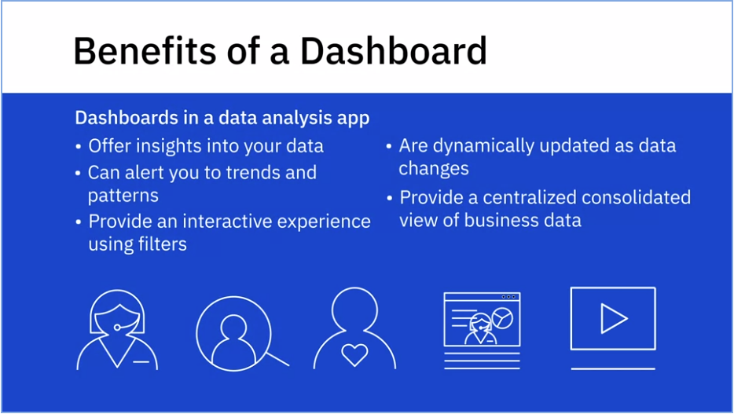

A dashboard can be a very useful tool in areas of the business such as fiscal forecasting and reporting, project management, executive reporting, human resources, customer service, helpdesk issue tracking, healthcare monitoring, call center analytics, social media marketing, and many more. For a budding data analyst, dashboards can be a vital skill to add their arsenal, as the majority of employers see the dashboarding skill as a ‘must have’ rather than a ‘nice to have’.

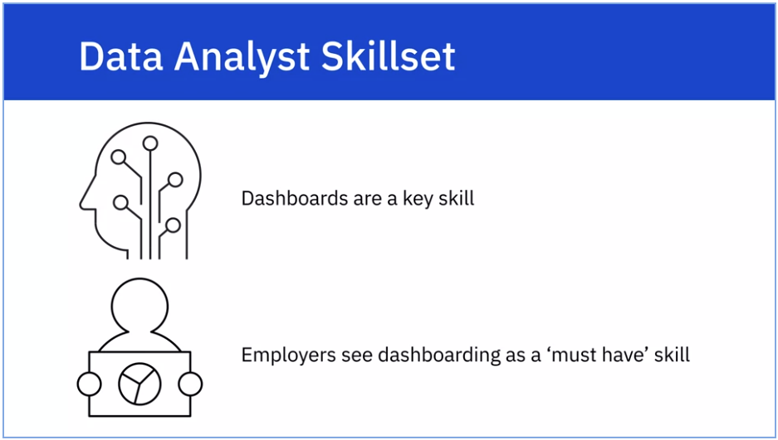

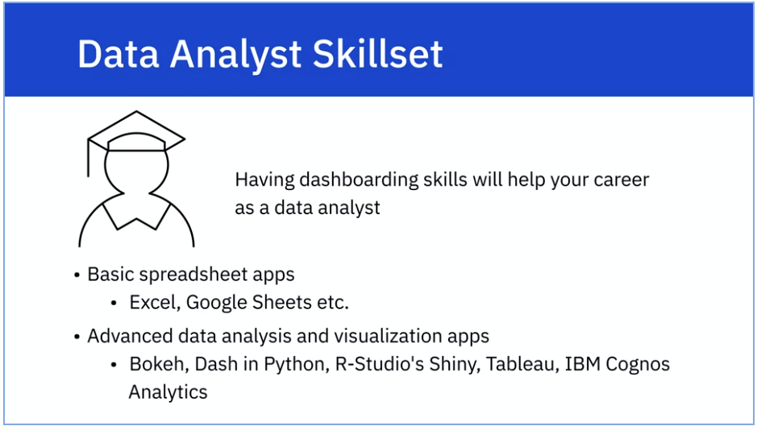

**Creating a Simple Dashboard** **using** **Excel**

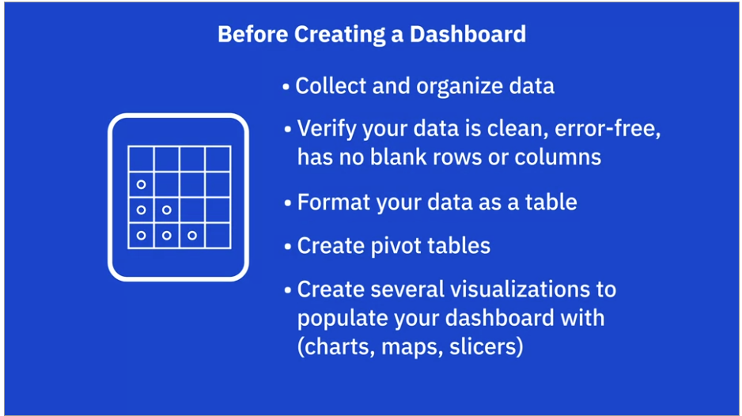

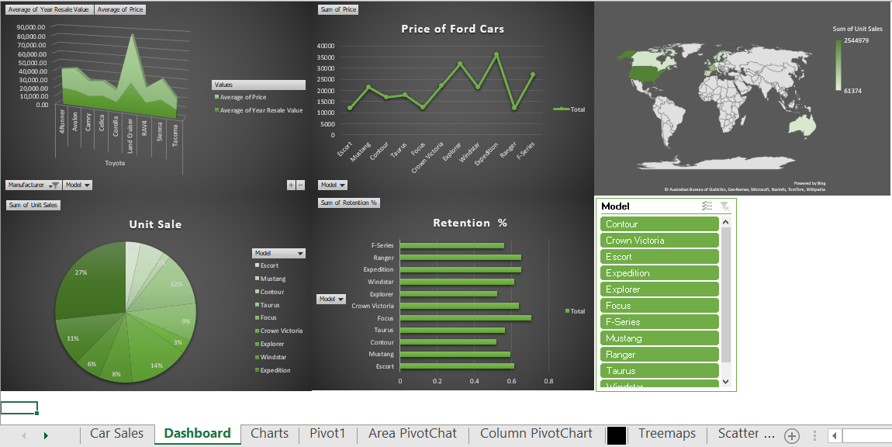

* *Important: Slicer and Timeline only work on PivotTable.
* Remove gridlines / headings: View tab > Show group > Uncheck Gridlines / Headings
* To standardize the color and theme of charts in Dashboard: Click to select the chart > click on Chart Styles > Style or Color (Preferred Monochromatic Palette 6)
* To change the color of slicer: Click on Slicer > Options of Slicer Tools > Slicer Styles group > Choose the color